Ethical Hacking Assignment – 2

Submittted By

Tanishq Vyas

SRN : PES1201800125
Section : H
Semester : 7th
Dept : CSE

Machines:

- Attacker Machine

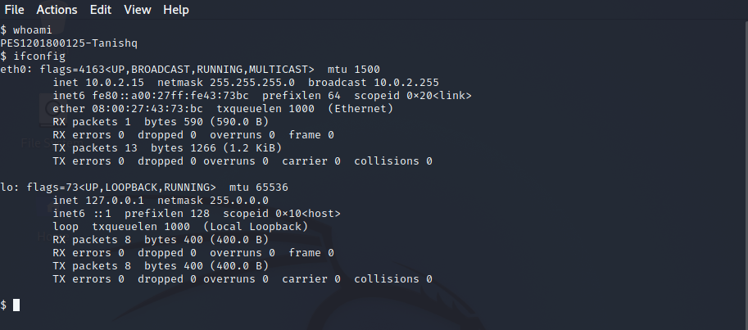

Attack Procedure:

a) Hackerbox-1

Step-1 : Open the Target machine

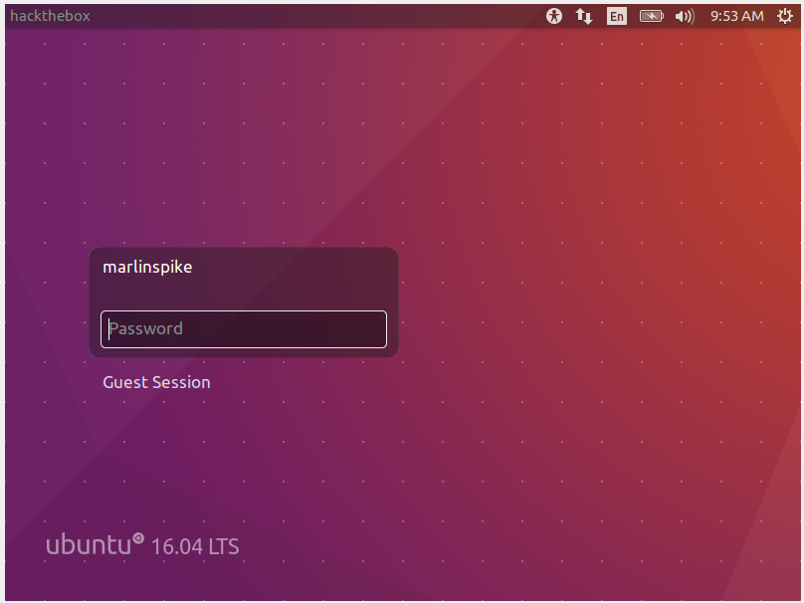

Step-2 : Search for live machines in the network

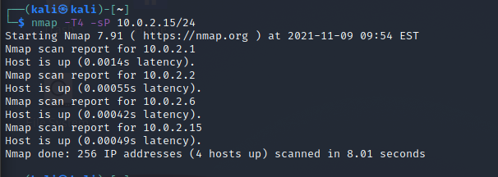
Our target machine is 10.0.2.6

Step-3 : Perform port scanning

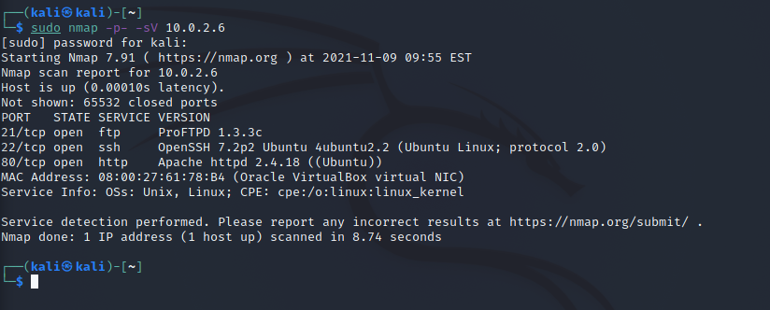
Step-4 : Now open Metasploit and search for proftpd to look for exploits for the FTP service.

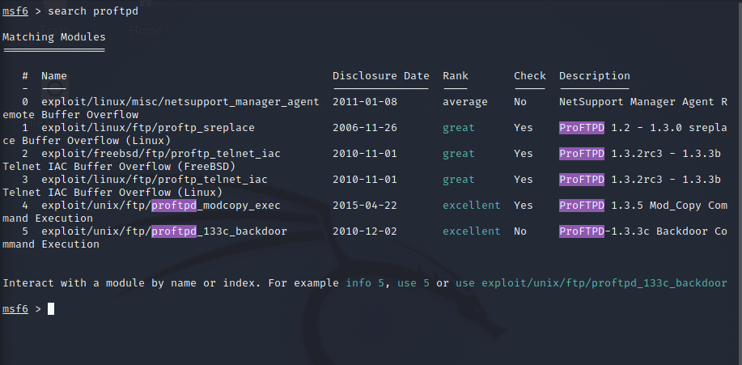

Step-5 : Use any one exploit and set the options

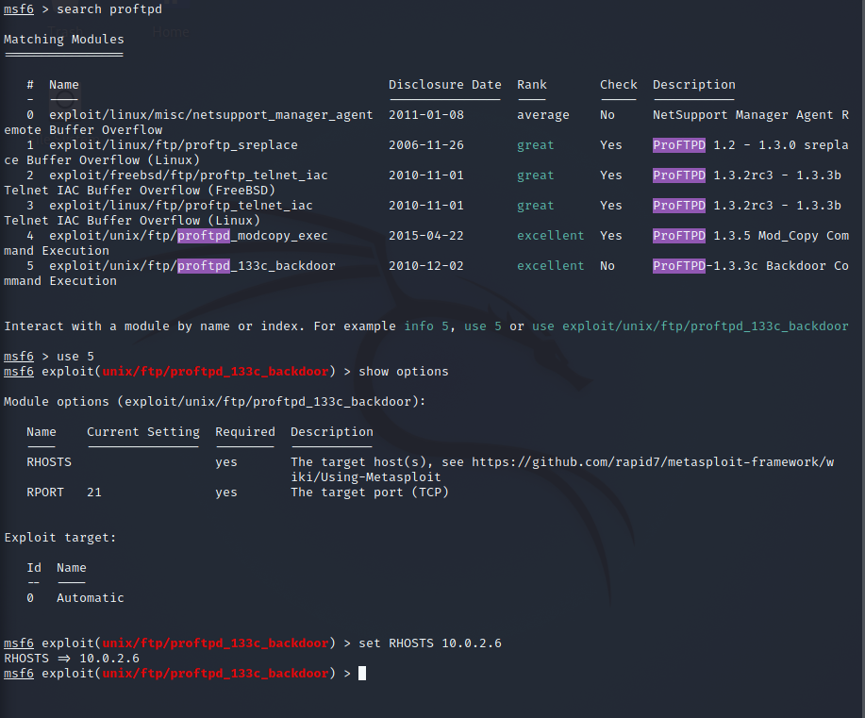

Step-6 : List the payloads and set the respective options

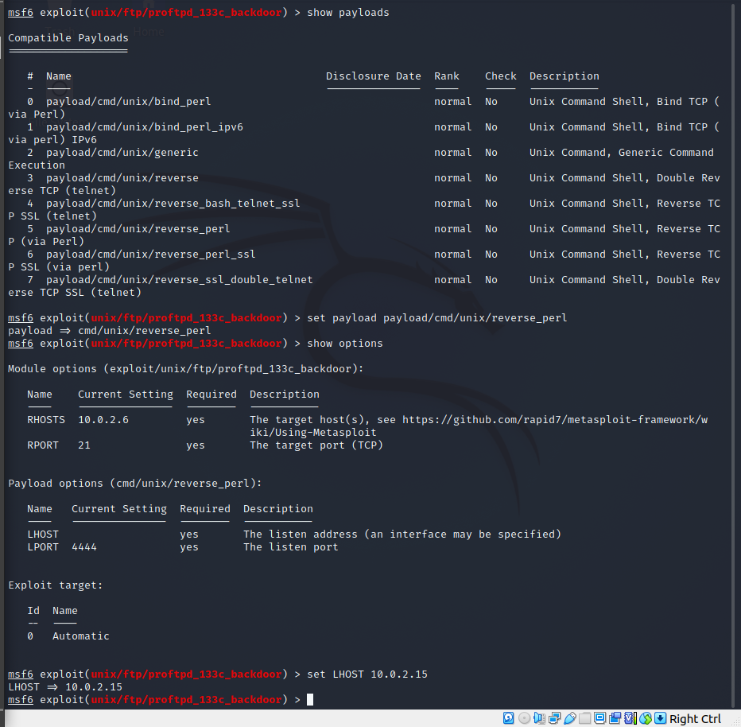
Step-7 : Run the exploit

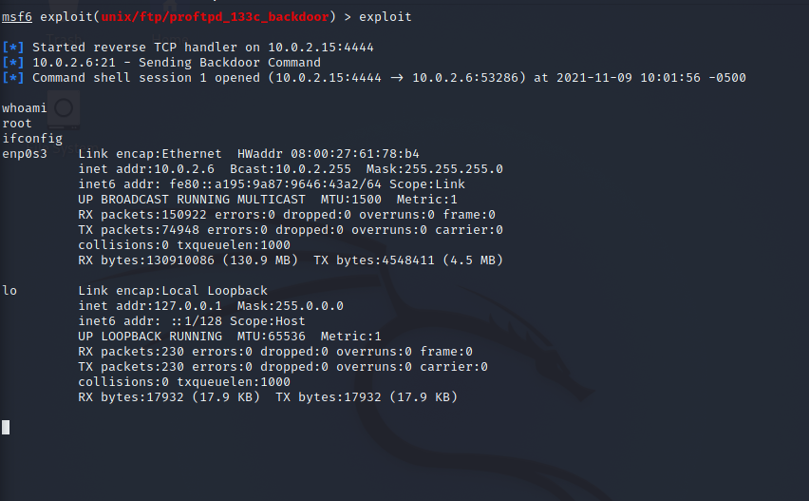

Step-8 : Finding the Flags

Flag-1:

Flag was present in a file named flag.txt present inside root
directory.
Flag value: flag{rea11y_1337_fl4g_w3ll_d0n3}

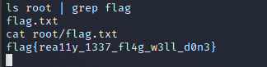

Flag-2:

Flag was present in the .bash_history file present inside
/home/marlinspike directory.
Flag value: flag{wh0_th0u9ht_4b0u7_h1st0ry}

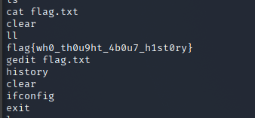

b) Hackerbox-2

Step-1 : Search for live machines in the network

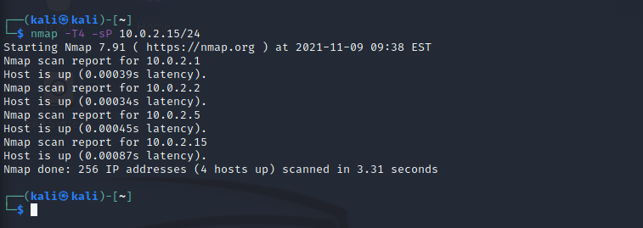
Our target machine is 10.0.2.5

Step-2 : Perform port scanning

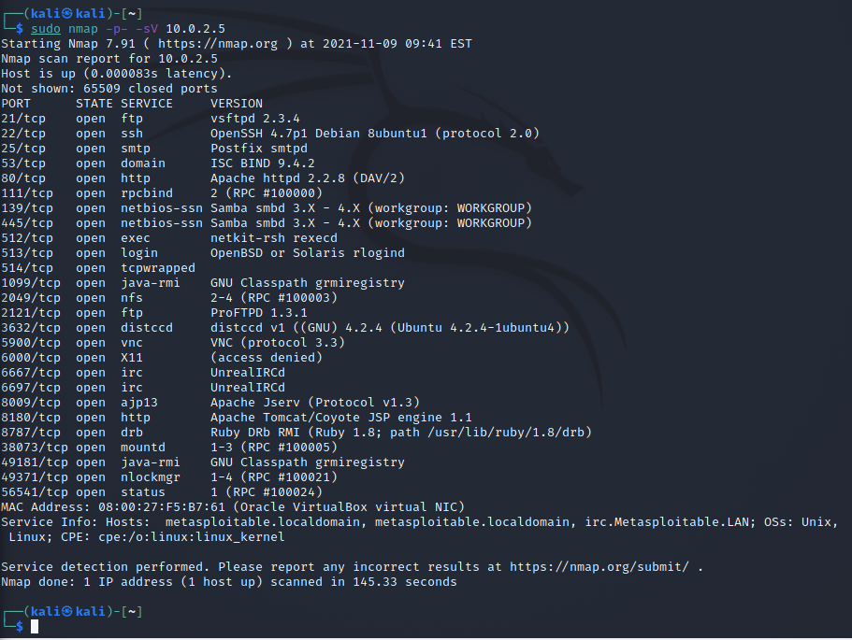

Step-3 : Get the rsh-client

sudo apt install rsh-client

Step-4 : Login into the victim machine remotely

sudo rlogin -l root 10.0.2.5

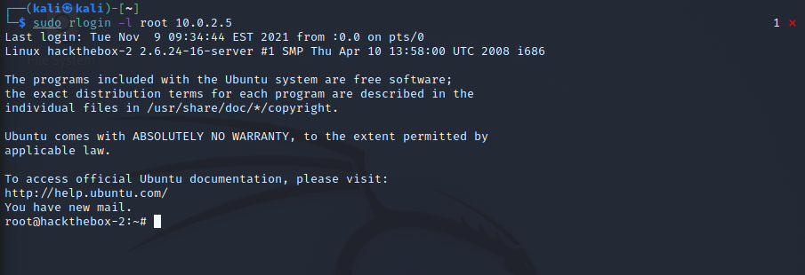
As we can see the terminal prompt changed to root@hackthebox-2

Now we have gained the access to the Target machine. Now we must find the flag.

Step-7 : Finding the flag

Flag-1:
Flag was found in flag-msfadmin file located at /home/msfadmin/
Flag value: flag{ea4y_p33sy_l3m0n_squ33zy}

Flag-2:
Flag was in a file named flag located /var/lib directory.

